New weekly food waste collections to start next year
After 31st March 2026 local councils will begin to offer weekly food waste collections to households. Provisional dates for district council collections in Cambridgeshire are as follows:
• Fenland and Huntingdonshire District Council start in March 2026
• Cambridge City and South Cambridgeshire start in April 2026
• East Cambs District Council starts in mid-2026
The government has given Councils money to spend on: • new collection vehicles • new waste containers, (kerbside and indoor caddies) • information detailing the changes for householders
Over ten million tonnes of food is wasted every year in the UK so separate collections of food waste will be sent to specialist facilities and not to landfill. Taking food waste to these facilities will generate energy to power homes and businesses and cut down the more than 18 million tonnes of greenhouse gas emissions.
How will the new policy work?
• Households will be given separate containers for food waste, and (in some areas) separate bins for paper and cardboard will also be introduced. Councils across Cambridgeshire will continue to collect dry recycling together in one bin.
• This will cut the amount of food waste going to landfill and will ensure smelly waste doesn’t sit in bins for weeks.
As part of this drive to educate residents about the new service we’re running a project with volunteers from across the five district councils, (East Cambridgeshire, Cambridge City, South Cambridgeshire, Fenland and Huntingdonshire) which will start in June 2025.
Sign up to become a food waste volunteer!
By 31 March 2026, food waste will be collected from most households every week, instead of once every two weeks. Food waste will then be collected separately from garden waste. As well as helping everyone think about the amount of food they purchase, we want food waste to be recycled effectively. We’re looking for volunteers to go out anytime, to talk to householders on their doorsteps and let them know about the new services. We’ll provide full training, as well as examples of the items that will be delivered by the district councils, to householders. If you’re interested in volunteering, just scan the QR code to sign up, (below)
Any personal data you submit will be kept in strict confidence in accordance with the data protection policies of the organisations involved.
Please scan this QR code with your mobile device to sign up, (this will take you to an online form to complete).

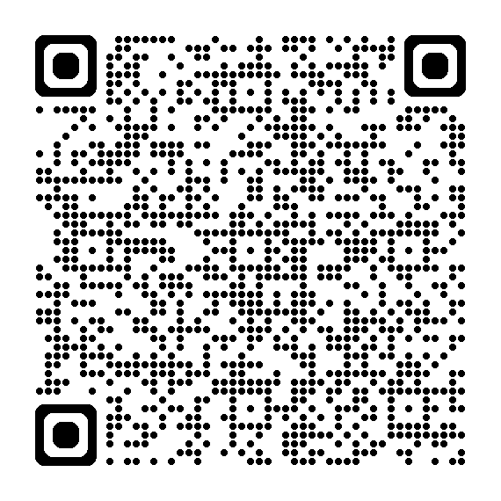
What else is changing?
• As of March 2025, all businesses must separate food waste from other waste
• Packaging will have mandatory recyclability labelling
• Manufacturers can include more recycled materials in their packaging.

